Weather permitting the LaGrange County officials are targeting Wednesday, October 2 for the aerial spray. Thursday October 3 is the backup date for the aerial spray. The spray is expected to happen at dusk as this is the activity time for the adult mosquitoes.
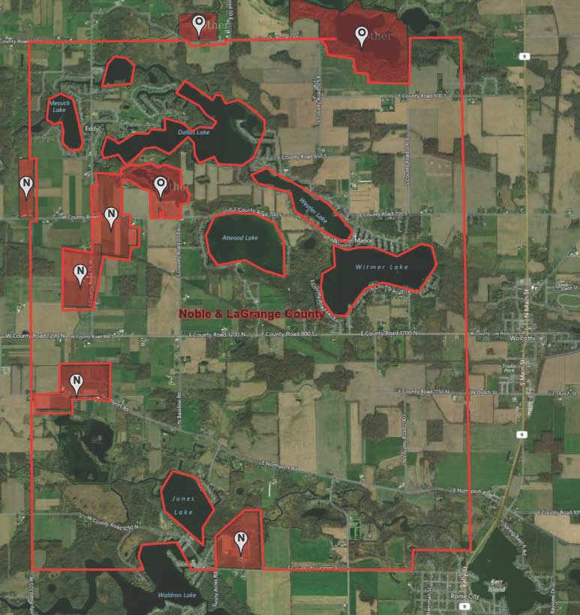
Bodies of water/lakes are areas negative for aerial spray, and also N & O (Organic or related type of farm).

